Universal Share
Pluggable widget for Mendix Studio Pro 10.24.17
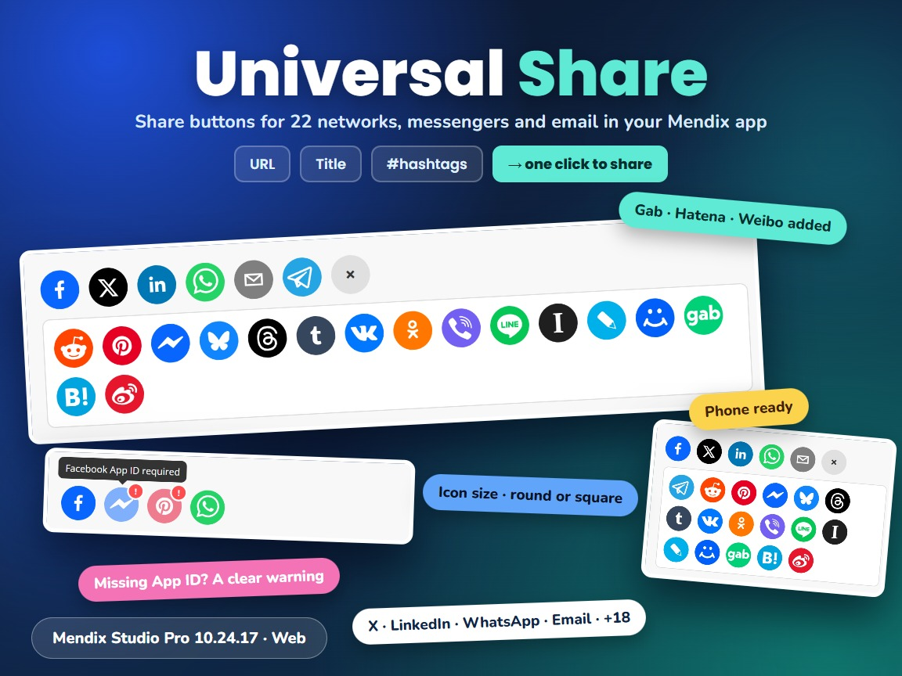
Item | Value
Widget version | 1.1.0
Studio Pro version | 10.24.17 (tested on 10.24.17.102810)
Widget ID | mendix.universalshare.UniversalShare
Widget package | mendix.UniversalShare.mpk (about 270 KB)
Platform | Web (offline capable)
Share library | react-share 5.3.0
Build tooling | @mendix/pluggable-widgets-tools 10.16.0
Source and downloads | github.com/bharathidas/UniversalShare

Contents
1. Overview 3
Typical uses 3
2. What is new in version 1.1.0 3
3. Requirements 4
4. Installation 4
4.1 Install the widget 4
4.2 Upgrade from version 1.0.0 4
5. Configuration 4
5.1 Add share buttons to a detail page 4
5.2 Recommended settings 5
6. Property reference 5
General – Content 5
General – Platforms 6
Appearance – Icons 6
Common and Visibility 6
Platforms that need a value 6
7. Examples 6
8. Styling 7
9. Known behaviour and limitations 8
10. Support and version history 8

1. Overview
Universal Share shows a row of share buttons for social networks, messengers and email. A click opens the share dialog of that platform with the URL, title, description, hashtags and image from attributes of the data view object. No API keys or server code are needed (only Messenger needs a Facebook App ID).
The platforms come from a String attribute with comma-separated names, so each page or object can show its own set, in its own order. The first six icons are shown in a row; the others open in a panel behind the + (More) button. 22 platforms are supported: Facebook, Messenger, X (Twitter), LinkedIn, WhatsApp, Telegram, Reddit, Pinterest, Email, Bluesky, Threads, Tumblr, VK, OK, Viber, LINE, Instapaper, LiveJournal, Mail.ru, Gab, Hatena and Weibo.
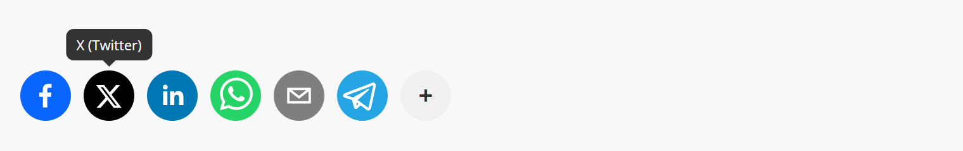
Figure 1. Default settings: six icons and the More button; the tooltip shows the platform

Typical uses
- Share buttons on product, article, event or job detail pages
- Letting users send a link to a record (for example a quote, a report or a form) by email, WhatsApp or Telegram
- Campaign and landing pages with hashtags for X, Threads and Facebook
- Portals where each object or customer group needs another set of platforms

2. What is new in version 1.1.0
- Rebuilt for Mendix Studio Pro 10.24.17 with @mendix/pluggable-widgets-tools 10.16.0 and react-share 5.3.0. The widget ID and property keys are unchanged, so existing pages keep their settings.
- Gab, Hatena and Weibo work. They were listed in the Studio Pro description of 1.0.0 but never shown.
- Pocket (closed by Mozilla in July 2025) and Workplace from Meta (closed in June 2026) are skipped; their buttons only led to closed services.
- Platform names ignore upper case and spaces, x can be used for X (Twitter), and duplicates are shown once. In 1.0.0 Facebook or LinkedIn showed nothing.
- Hashtags are cleaned: spaces and a leading # are removed ( #mendix, low code becomes mendix and lowcode). 1.0.0 passed the raw text, which broke the hashtags on X. Facebook now gets the first hashtag; Threads and Bluesky get the hashtags in the text.
- Empty URL shares the page the user is on. In 1.0.0 a click on a share button with an empty URL caused an error.
- More platforms get the title, description and image: Pinterest (description), Tumblr (caption and tags), VK, OK, Mail.ru and Weibo (image), Instapaper and LiveJournal (description).
- New properties: Icon size (default 40), Round icons (default Yes) and Icons before More (default 6; 0 shows all icons).
- The More panel closes with Escape or a click outside the widget. Tooltips also show on keyboard focus.
- The class and style set in Studio Pro are applied. Studio Pro design mode shows example icons. Clearer captions and descriptions (1.0.0: "My widget description").
Version 1.1.0 was tested in a Mendix 10.24.17 app with 27 automated checks; version 1.0.0 fails 17 of them (some of them are the new properties). The checks cover all platform names of the description, case and spaces, aliases and duplicates, the More panel, Messenger and Pinterest without the required values, the share links of X, Facebook, LinkedIn, Pinterest, Threads, Weibo and Telegram, an empty URL, tooltips, class and style, the console, the new properties and a phone-sized window. The screenshots in this document are from that test app.

3. Requirements
- Mendix Studio Pro 10.24.17 or a later 10.24 version.
- A web profile. The widget is not available for native mobile.
- The widget must be inside a data view (or another widget that gives an object) with String attributes for the URL, title and the other values. No other modules are needed.
- Messenger needs a Facebook App ID (from developers.facebook.com). Pinterest needs an image URL.

4. Installation

4.1 Install the widget
- Download mendix.UniversalShare.mpk from the Mendix Marketplace or from the GitHub release Version1.1.0.
- Copy the file into the widgets folder of your app. To find the folder, use App > Show App Directory in Explorer in Studio Pro.
- In Studio Pro, choose App > Synchronize App Directory (F4).
- The widget appears in the Toolbox as Universal Share (category Display).

4.2 Upgrade from version 1.0.0
- Replace mendix.UniversalShare.mpk in the widgets folder with the 1.1.0 file.
- Synchronize the app directory (F4).
- Studio Pro reports that the widget definition has changed. Right-click the error and choose Update all widgets. Your settings are kept; the new properties get their defaults (Icon size 40, Round icons Yes, Icons before More 6), which look like 1.0.0.
- If the running app still shows the old widget, stop it, choose App > Clean Deployment Directory, and run it again.
Check after upgrading: pocket and workplace in the Platforms attribute are now skipped, so those pages show one or two icons fewer. gab, hatena and weibo now appear. With an empty URL the buttons now share the current page.

5. Configuration

5.1 Add share buttons to a detail page
- Give the entity String attributes for the values you want to share, for example ShareURL, ShareTitle, ShareText, Hashtags and SharePlatforms, or use a non-persistent helper entity.
- Fill them in the microflow or nanoflow that opens the page, or give them default values in the domain model. Example for Platforms: facebook,x,linkedin,whatsapp,email,telegram,reddit,pinterest.
- Put a data view of that entity on the page and drag Universal Share from the Toolbox into it.
- On the General tab, select the attributes for URL, Title, Description, Hashtags, Image URL, Facebook App ID and Platforms. Only Platforms is required.
- Optional: on the Appearance tab, set Icon size, Round icons and Icons before More.
The URL must be a public address that the platform can open, for example a page URL of your app with the object in it. A localhost URL can be shared, but the platform cannot show a preview of it.

5.2 Recommended settings
Use | Settings
Product or article page | Platforms facebook,x,linkedin,whatsapp,email,pinterest, Image URL set, Icons before More 6
Compact row in a card or list | Icon size 28, Icons before More 4
All icons in one block | Icons before More 0, Round icons No, Icon size 48
Internal links (record, report) | Platforms email,whatsapp,telegram, Description with a short message
Users in Japan, China, Russia | Add line,hatena, weibo or vk,ok,mailru to the list

6. Property reference

General – Content
Property | Type | Description (default)
URL | String attribute | The URL to share. (Empty: the URL of the current page)
Title | String attribute | Title or message. Used by X, LinkedIn, WhatsApp, Telegram, Reddit, Bluesky, Threads and most other platforms, and as the email subject.
Description | String attribute | Longer text. Email body; also used by LinkedIn, Pinterest, Tumblr, OK, Mail.ru, Instapaper and LiveJournal.
Hashtags | String attribute | Comma-separated hashtags, for example mendix,lowcode; a leading # and spaces are removed. Used by X and Tumblr, added to the text for Threads and Bluesky; Facebook uses the first one.
Image URL | String attribute | URL of an image. Required for Pinterest; also used by VK, OK, Mail.ru and Weibo.
Facebook App ID | String attribute | Your Facebook App ID. Required for Messenger.

General – Platforms
Property | Type | Description (default)
Platforms | String attribute | Comma-separated platform names, in the order they are shown: facebook, messenger, twitter (or x), linkedin, whatsapp, telegram, reddit, pinterest, email, bluesky, threads, tumblr, vk, ok, viber, line, instapaper, livejournal, mailru, gab, hatena, weibo. Case and spaces are ignored; unknown names and duplicates are skipped. Required.

Appearance – Icons
Property | Type | Description (default)
Icon size | Integer | Size of the icons in pixels, 16 to 128. (40)
Round icons | Boolean | Yes: round icons. No: square icons with rounded corners. (Yes)
Icons before More | Integer | Number of icons before the + (More) button; the others open in a panel below. 0 shows all icons without a More button. (6)

Common and Visibility
Property | Type | Description
Name | System | Name of the widget; also gives the class mx-name-<name>.
Class and Style | System | Applied to the outer element of the widget.
Visibility | System | Default or Conditionally.

Platforms that need a value
When the required value is empty, the icon is shown faded with a red ! badge and cannot be clicked. The tooltip says what is missing.
Platform | Needs | Tooltip when missing
Messenger | Facebook App ID | Facebook App ID required
Pinterest | Image URL | Image URL required

7. Examples
Figure 2. Default settings: six icons, the More button and a tooltip
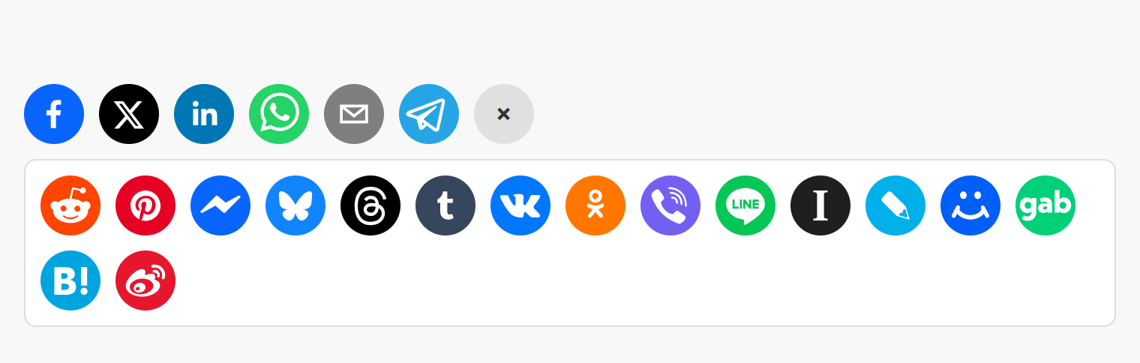
Figure 3. The More panel with the other 16 platforms
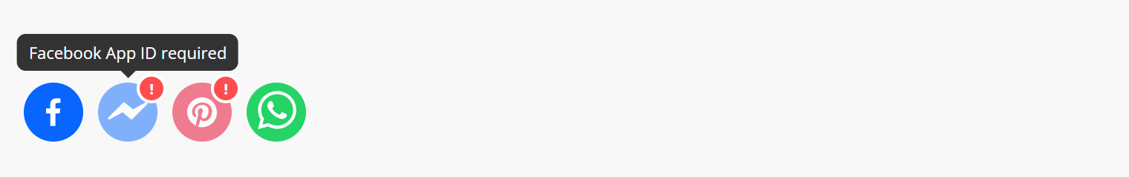
Figure 4. Messenger without App ID and Pinterest without Image URL
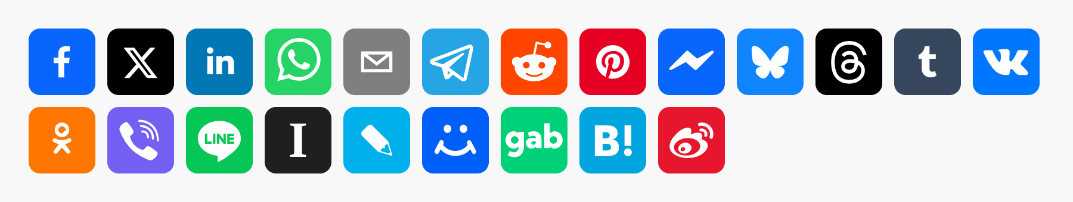
Figure 5. Icon size 56, Round icons No, Icons before More 0
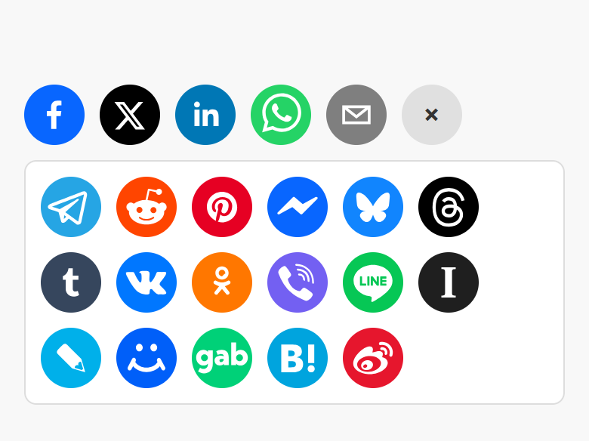
Figure 6. Phone width with Icons before More 5 and the panel open

8. Styling
The widget renders these elements. The class and style from Studio Pro are applied to the outer element.
<div class="widget-universalshare mx-name-universalShare1 your-class">
<div class="us-grid">
<div class="us-item us-item-facebook">
<div class="us-tooltip-wrapper">
<button class="react-share__ShareButton" aria-label="Facebook"><svg>...</svg></button>
<div class="us-tooltip">Facebook</div>
</div>
</div>
... (us-item-disabled with us-badge when a value is missing)
<div class="us-item"><button class="us-more-btn">+</button></div>
</div>
<div class="us-popup"> ... more us-item elements ... </div>
</div>
Example theme classes: icons left-aligned in a card footer, a dark More button and no tooltips.
.card-footer .widget-universalshare .us-grid { justify-content: flex-end; }
.widget-universalshare .us-more-btn { background: #0f2547; }
.widget-universalshare .us-more-icon { color: #fff; }
.widget-universalshare .us-tooltip { display: none; }

9. Known behaviour and limitations
- Web only; not available in native mobile apps.
- The widget opens the share page of each platform in a pop-up window; what the user sees there (preview image, text) is decided by the platform. Most platforms read the preview from the Open Graph tags of the shared URL, not from the Title or Image URL.
- Facebook shares only the URL and one hashtag; Facebook ignores the title and description.
- Instagram, TikTok and Snapchat have no web share link and are not supported.
- Pocket and Workplace from Meta are closed services; their names are skipped.
- Email opens the user's mail program with a mailto link; it does not send mail itself.
- Platform labels and tooltips are in English.
- Studio Pro design mode shows example icons, because the platforms come from an attribute that is only known at run time.

10. Support and version history
Report issues, suggestions and feature requests on GitHub:
https://github.com/bharathidas/UniversalShare/issues
Source code and all releases:
https://github.com/bharathidas/UniversalShare
Widget | Studio Pro | GitHub release | Changes
1.1.0 | 10.24.17 | Version1.1.0 | Rebuilt for Studio Pro 10.24.17 with react-share 5.3.0; Gab, Hatena and Weibo work; Pocket and Workplace skipped; platform names ignore case and spaces, x alias, no duplicates; clean hashtags; empty URL shares the current page; more platforms get title, description and image; Icon size, Round icons and Icons before More; More panel closes with Escape or outside click; class and style applied; design-mode preview.
1.0.0 | 10.18.4 | Version1.0.0 | First release.

